# Automating Fabric Solution Deployment

This document is designed to help you understand essential concepts with Fabric CI/CD.

Ddd

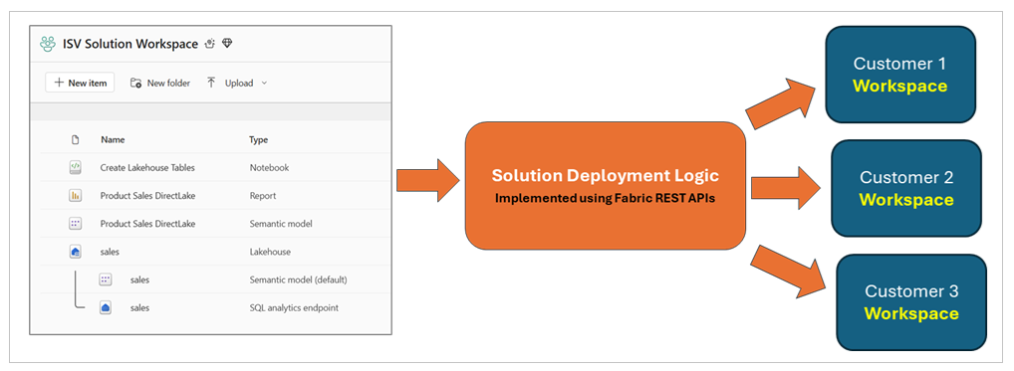

Preview what we will be using from Fabric REST APIs.

Create workspaces using the **Create Workspace** API.

Create connection using the **Create Connections** API. .

Create workspace items using item definitions and the **Create Item** API.

Retrieve item definitions using the **Get Item Definition** API.

Update the definition for existing workspace items using the **Update Item Definition** API.

Here are the demonstration deployment workflows

* Demo 1 - Deploy Fabric Solutions using Item Definitions
* Demo 2 - Deploy Fabric Solutions using Workspace Template
* Demo 3 – Deploy Fabric Solutions using Source Control with Item Definition Files

Demo 1 - Deploy solutions using item definitions

***graphic***

Demo 2 - Deploy solutions using Workspace Template

***graphic***

Demo 3 – Deploy solutions using Item Definitions from Source Control

***graphic***

## Managing Workspace Item Dependencies

With a Fabric workspace, workspace items will often have dependencies on other workspace items. For example,

When deploying a solutions, you must understand these dependencies.

* **Lakehouse** has no dependencies on other workspace items
* **Notebook** has dependencies on workspace id & lakehouse id of default lakehouse
* **DirectLake semantic model** depends on SQL endpoint connect string and database Id
* **DirectLake semantic model** might depend on running a notebook to create lakehouse tables
* **Report** depends on id of semantic model to which it is bound

When cloning a

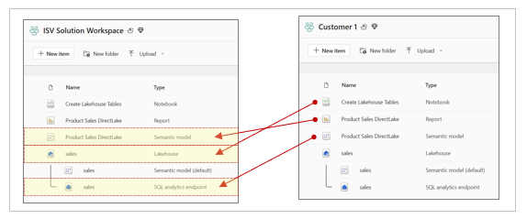

xxx

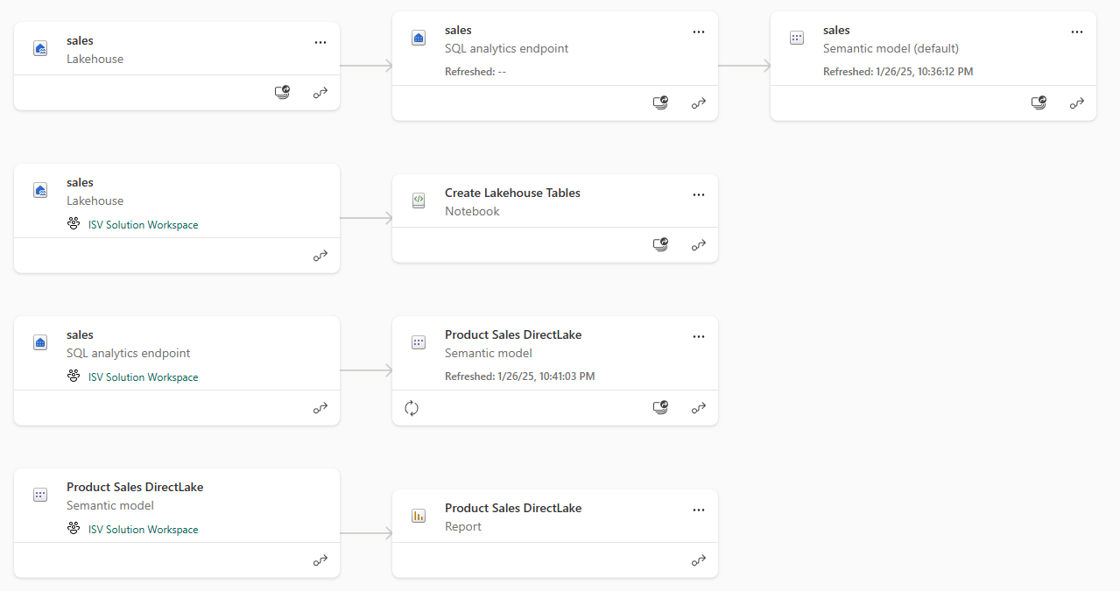

Item

For this reason, a Fabric solution must deploy its workspace items in this order

* Lakehouses
* Notebooks
* Semantic models
* Reports

And now a little more detail about the workflow

* Create lakehouse
  + Track lakehouse id for later use when updating notebook dependency
  + Track lakehouse properties which provide connection information for SQL endpoint
  + Track lakehouse name to later determine which semantic models are default for lakehouse
* Create notebooks
  + Create notebook using item definition which is updated to include workspace id & lakehouse id
  + Run notebook and monitor execution until completion to ensure lakehouse tables are created
* Create DirectLake semantic models
  + Create semantic model using updated item definition that includes SQL endpoint connect string
  + Track semantic model id for later use when binding report
  + Create SQL connection to lakehouse SQL endpoint and bind it to semantic model
  + Refresh semantic model
* Create Power BI reports
  + Create report using updated item definition that includes semantic model id

Summary of section

## Demo 1 - Deploy Fabric Solutions using Item Definitions

## Demo 2 - Deploy Fabric Solutions using Workspace Template

## Demo 3 – Deploy Fabric Solutions using Source Control with Item Definition Files